Spring Testing

1.Basic unit test for a Service Method

CalculatorService.java
@Service
public class CalculatorService {
public int add(int a, int b) {
return a + b;
}
}

CalculatorServiceTest.java
public class CalculatorServiceTest {
@Test

public void testAdd() {
CalculatorService calculatorService = new CalculatorService();

int result = calculatorService.add(5, 3);
assertEquals(8, result, "5 + 3 should equal 8");
}
}
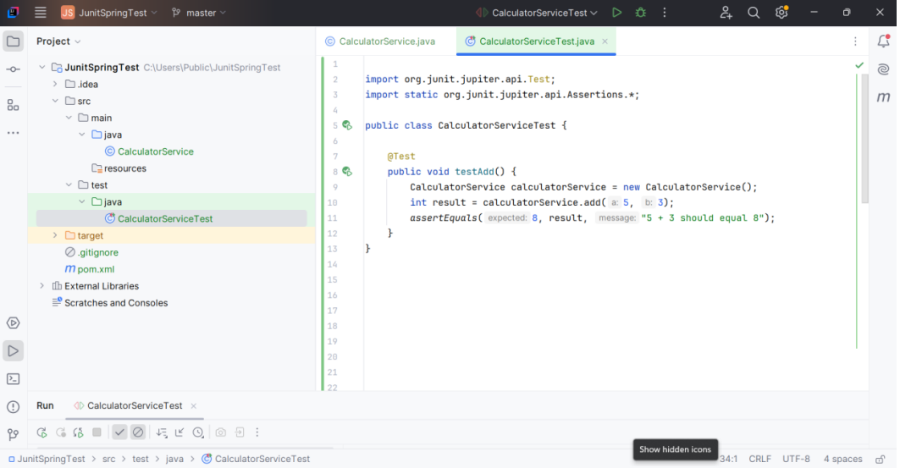

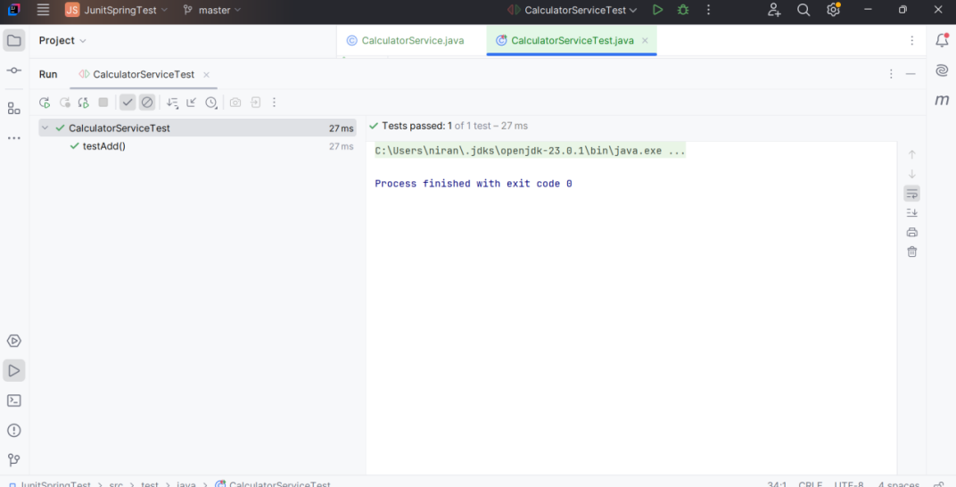

2.Basic unit test for a Service Method

User.java
@Entity
public class User {
@Id
private Long id;
private String name;

public Long getId() {
return id;
}
public void setId(Long id) {
this.id = id;
}
public String getName() {
return name;
}
public void setName(String name) {
this.name = name;
}
}
UserRepository.java
package com.calculator.repository;

import com.calculator.model.User;
import org.springframework.data.jpa.repository.JpaRepository;

public interface UserRepository extends JpaRepository<User, Long> {
}

UserService.java
import com.calculator.model.User;
import com.calculator.repository.UserRepository;
import org.springframework.beans.factory.annotation.Autowired;
import org.springframework.stereotype.Service;

@Service
public class UserService {

@Autowired
private UserRepository userRepository;

public User getUserById(Long id) {
return userRepository.findById(id).orElse(null);
}
}

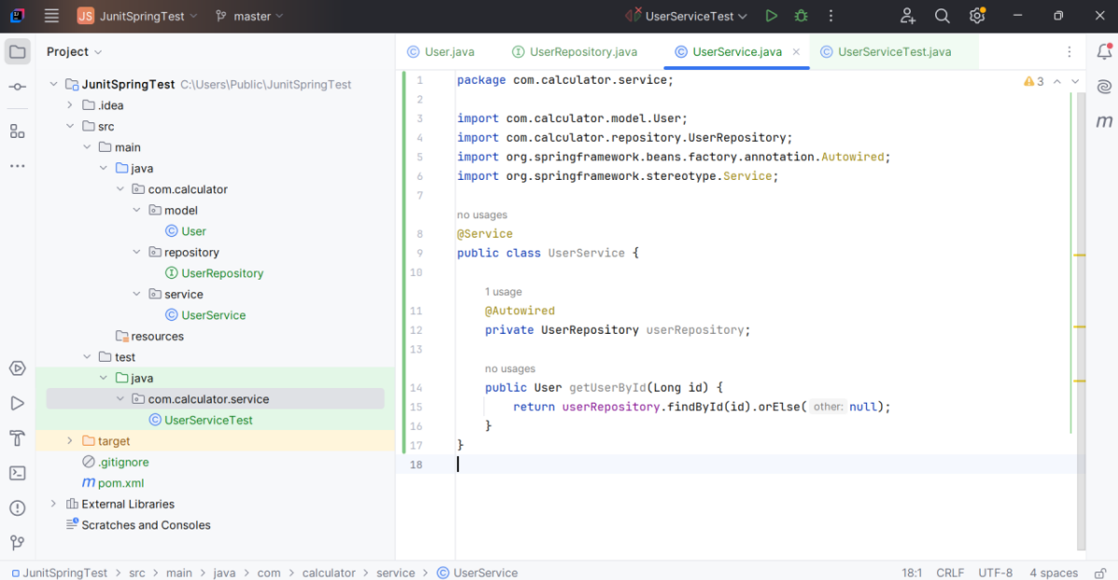

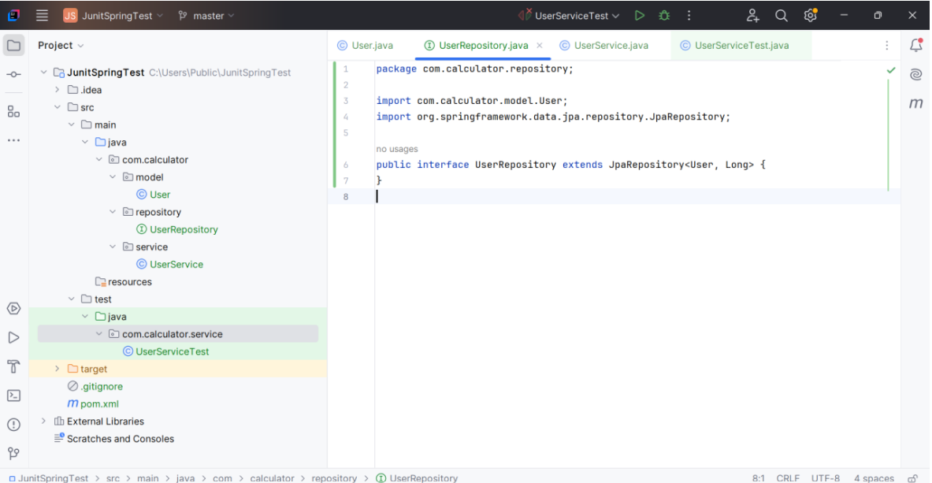

3.Testing a REST controller with Mockmvc

UserServiceTest.java
import com.calculator.model.User;
import com.calculator.repository.UserRepository;
import org.junit.jupiter.api.Test;
import org.junit.jupiter.api.extension.ExtendWith;
import org.mockito.InjectMocks;
import org.mockito.Mock;
import org.mockito.junit.jupiter.MockitoExtension;

import java.util.Optional;

import static org.junit.jupiter.api.Assertions.*;
import static org.mockito.Mockito.*;

@ExtendWith(MockitoExtension.class)
public class UserServiceTest {

@Mock
private UserRepository userRepository;

@InjectMocks
private UserService userService;

@Test
void testGetUserById_ReturnsUser() {
Long id = 1L;
User user = new User();
user.setId(id);
user.setName("Alice");

when(userRepository.findById(id)).thenReturn(Optional.of(user));

User result = userService.getUserById(id);

assertNotNull(result);
assertEquals("Alice", result.getName());
verify(userRepository).findById(id);
}

@Test
void testGetUserById_ReturnsNullWhenNotFound() {
Long id = 2L;

when(userRepository.findById(id)).thenReturn(Optional.empty());

User result = userService.getUserById(id);

assertNull(result);
verify(userRepository).findById(id);
}
}

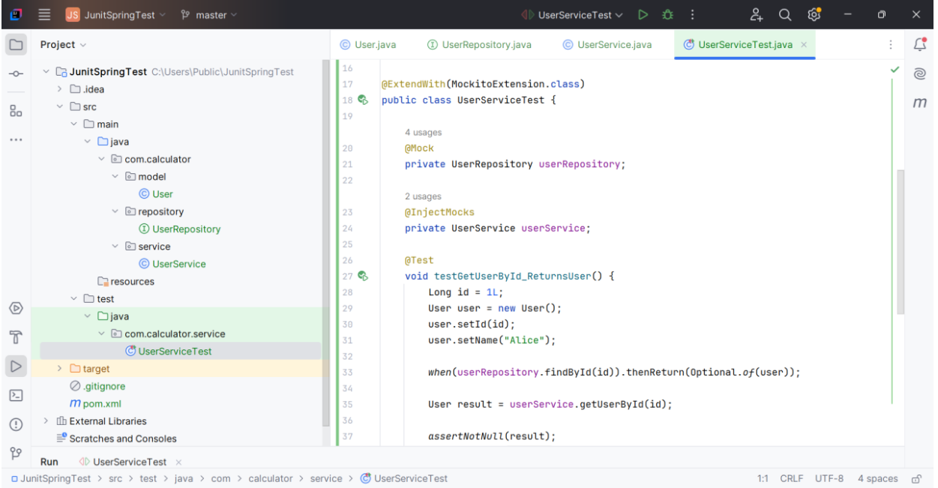

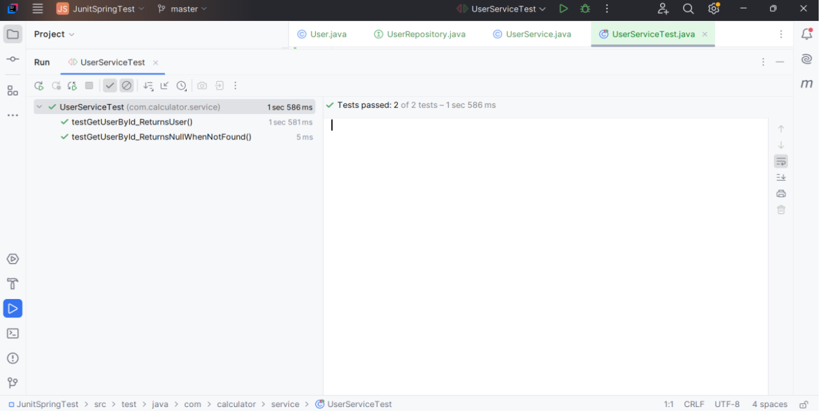

4.Integration test with Spring boot

UserIntegrationTest.java
@SpringBootTest(webEnvironment =
SpringBootTest.WebEnvironment.RANDOM_PORT)
public class UserIntegrationTest {

@LocalServerPort
private int port;

@Autowired
private TestRestTemplate restTemplate;

@Autowired
private UserRepository userRepository;

@Test
public void testSaveAndGetUser() {
User user = new User();
user.setName("Test User");

HttpHeaders headers = new HttpHeaders();
headers.setContentType(MediaType.APPLICATION_JSON);

HttpEntity<User> request = new HttpEntity<>(user, headers);

ResponseEntity<User> response = restTemplate.postForEntity("http://localhost:" + port + "/api/users", request, User.class);

assertThat(response.getStatusCode()).isEqualTo(HttpStatus.OK);
assertThat(response.getBody()).isNotNull();
assertThat(response.getBody().getName()).isEqualTo("Test User");

Long id = response.getBody().getId();
User retrieved = restTemplate.getForObject("http://localhost:" + port + "/api/users/" + id, User.class);
assertThat(retrieved).isNotNull();
assertThat(retrieved.getName()).isEqualTo("Test User");
}
}

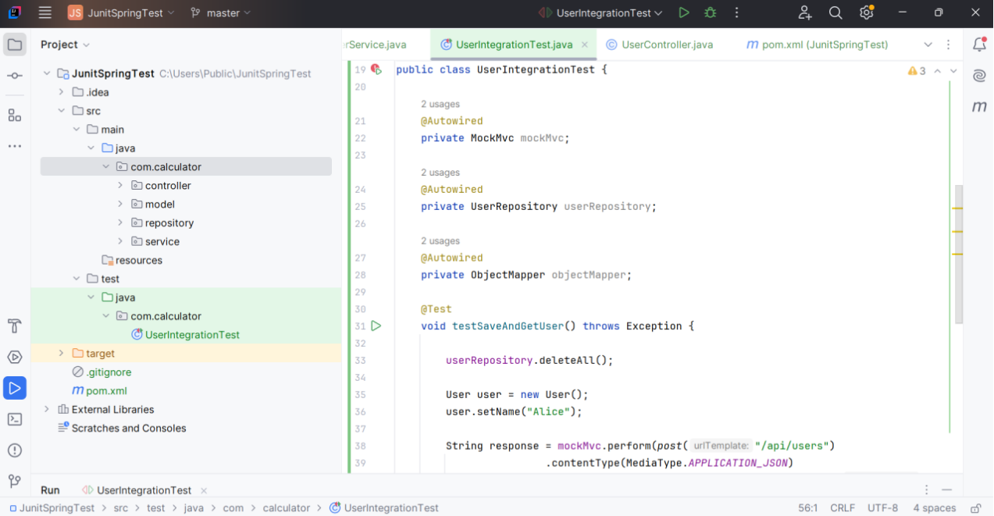

5.Test Controller POST Endpoint

UserIntegrationTest.java
import com.calculator.model.User;
import com.calculator.repository.UserRepository;
import org.junit.jupiter.api.Test;
import org.springframework.beans.factory.annotation.Autowired;
import org.springframework.boot.test.context.SpringBootTest;
import org.springframework.boot.test.web.client.TestRestTemplate;
import org.springframework.http.*;
import static org.junit.jupiter.api.Assertions.*;
@SpringBootTest(webEnvironment = SpringBootTest.WebEnvironment.RANDOM_PORT)
public class UserIntegrationTest {
@Autowired
private TestRestTemplate restTemplate;
@Autowired
private UserRepository userRepository;
@Test
public void testSaveAndGetUser() {
User user = new User();
user.setName("Ninja");
ResponseEntity<User> response = restTemplate.postForEntity("/api/users", user, User.class);
assertEquals(HttpStatus.OK, response.getStatusCode());
User savedUser = response.getBody();
assertNotNull(savedUser);
assertNotNull(savedUser.getId());
assertEquals("Ninja", savedUser.getName());
ResponseEntity<User> fetched = restTemplate.getForEntity("/api/users/" + savedUser.getId(), User.class);
assertEquals(HttpStatus.OK, fetched.getStatusCode());
assertEquals("Ninja", fetched.getBody().getName());
}
}

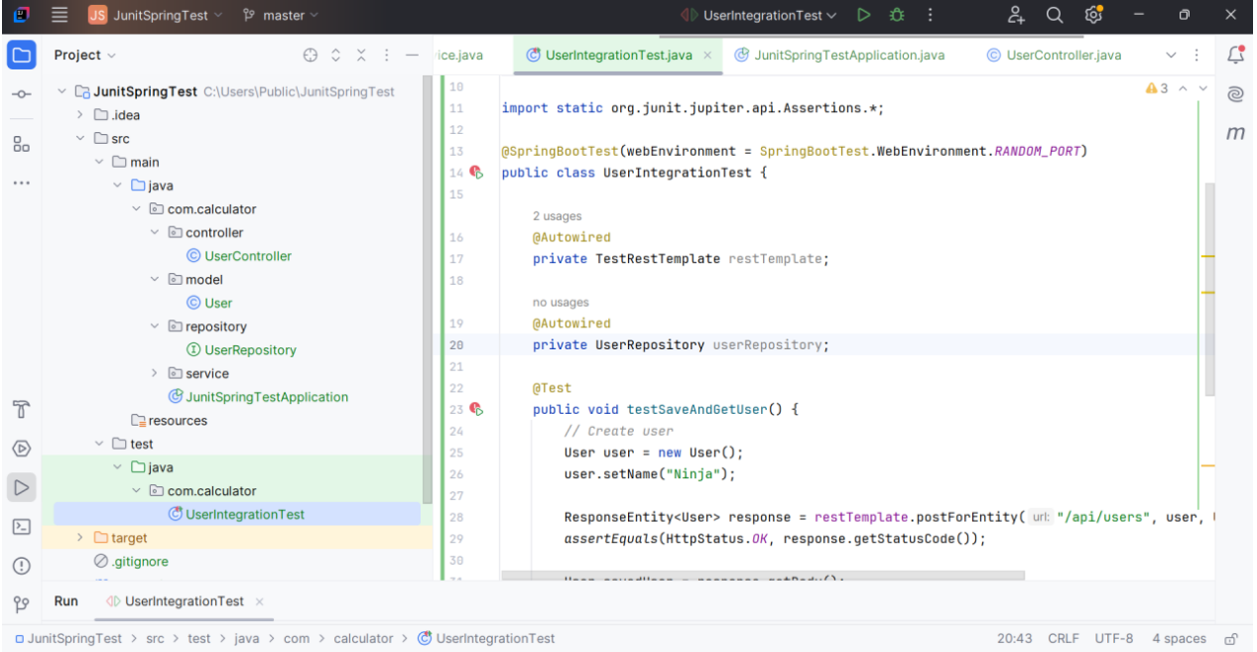

6.Test Service Exception Handling

UserIntegrationTest.java
@SpringBootTest
@AutoConfigureMockMvc
public class UserIntegrationTest {
@Autowired
private MockMvc mockMvc;

@Autowired
private UserRepository userRepository;

@Test
public void testSaveAndGetUser() throws Exception {

String json = "{\"name\": \"John\"}";

mockMvc.perform(post("/api/users")
.contentType(MediaType.APPLICATION_JSON)
.content(json))
.andExpect(status().isOk())
.andExpect(jsonPath("$.id").exists())
.andExpect(jsonPath("$.name").value("John"));
}
}

UserControllerTest.java
@WebMvcTest(UserController.class)
public class UserControllerTest {

@Autowired
private MockMvc mockMvc;

@MockBean
private UserService userService;

@Autowired
private ObjectMapper objectMapper;

@Test
public void createUser_returnsOk() throws Exception {
User user = new User("TestUser");
user.setId(1L);

when(userService.saveUser(user)).thenReturn(user);

mockMvc.perform(post("/api/users")
.contentType(MediaType.APPLICATION_JSON)
.content(objectMapper.writeValueAsString(user)))
.andExpect(status().isOk())
.andExpect(jsonPath("$.id").value(1L))
.andExpect(jsonPath("$.name").value("TestUser"));
}
}

UserServiceExceptionTest.java
public class UserServiceExceptionTest {
csharp
CopyEdit
@Mock
private UserRepository userRepository;

@InjectMocks
private UserService userService;

public UserServiceExceptionTest() {
MockitoAnnotations.openMocks(this);
}

@Test
public void getUserById_userNotFound_throwsException() {
Long userId = 1L;
when(userRepository.findById(userId)).thenReturn(Optional.empty());
assertThrows(UserNotFoundException.class, () -> {
userService.getUserById(userId);
});
}

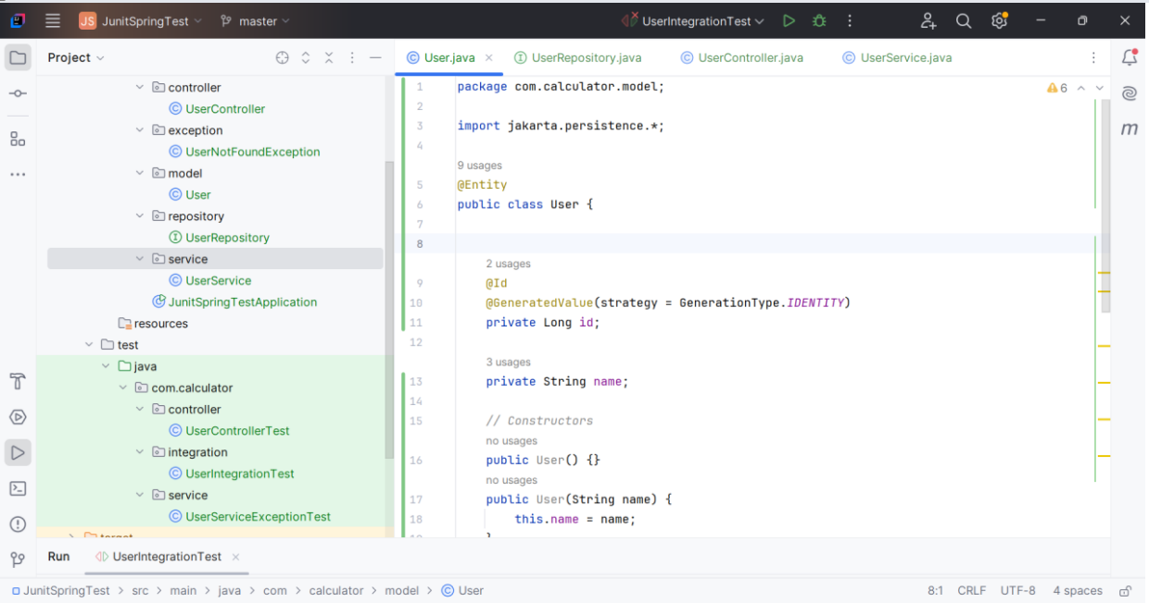

6.Test Custom Repository Query

UserRepositoryTest.java
import com.example.demo.model.User;
import org.junit.jupiter.api.BeforeEach;
import org.junit.jupiter.api.Test;
import org.springframework.beans.factory.annotation.Autowired;
import org.springframework.boot.test.autoconfigure.orm.jpa.DataJpaTest;

import java.util.List;

import static org.assertj.core.api.Assertions.assertThat;

@DataJpaTest
public class UserRepositoryTest {

@Autowired
private UserRepository userRepository;

@BeforeEach
public void setUp() {
userRepository.save(new User(null, "Alice"));
userRepository.save(new User(null, "Bob"));
userRepository.save(new User(null, "Alice"));
}
@Test
public void testFindByName() {
List<User> usersNamedAlice = userRepository.findByName("Alice");

assertThat(usersNamedAlice).hasSize(2);
assertThat(usersNamedAlice).allMatch(user -> user.getName().equals("Alice"));
}
}

